2.What is the difference between cat and more command?

* Cat displays file contents. If the file is large the contents we will scroll. But More displays the contents page by page

3.What is the difference between rm and rmdir using man?

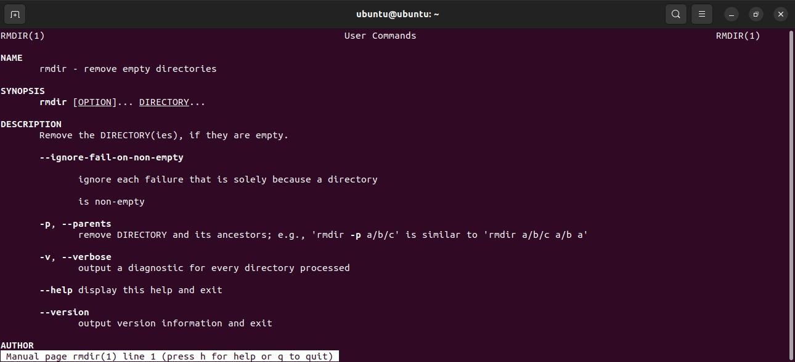

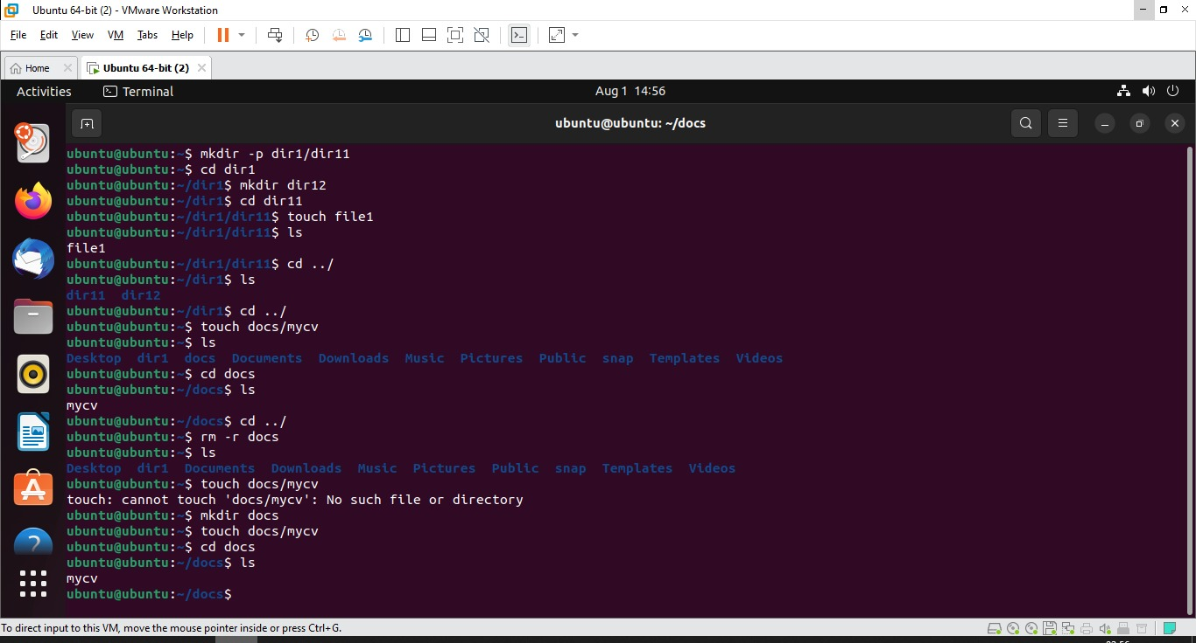4. Create the following hierarchy under your home directory: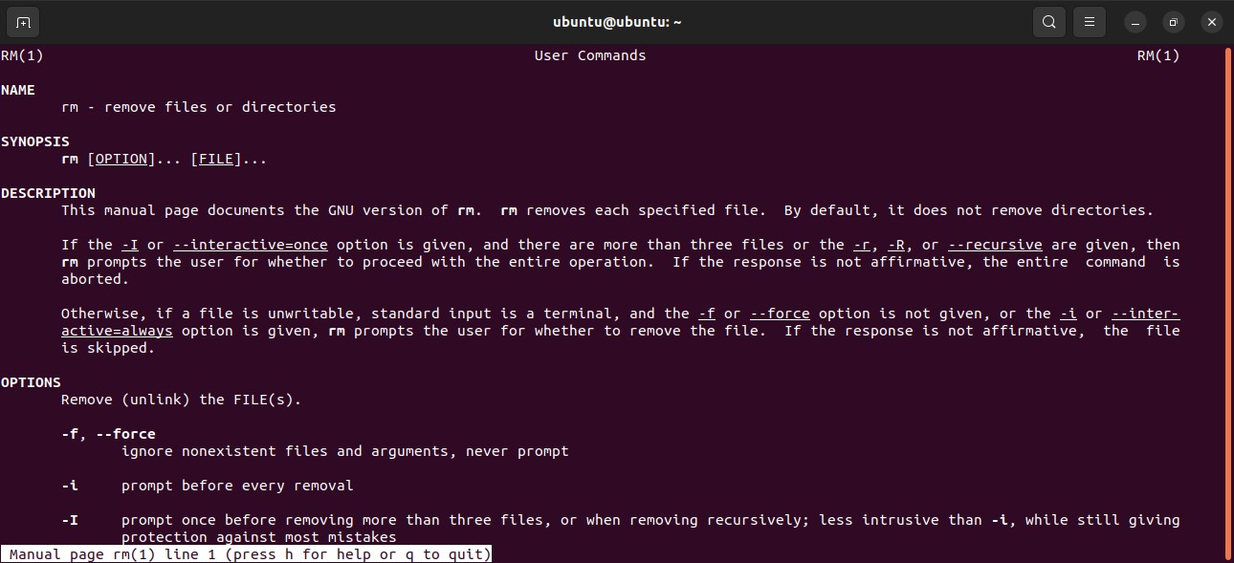

1. Remove dir11 in one-step. What did you notice? And how did you overcome that?

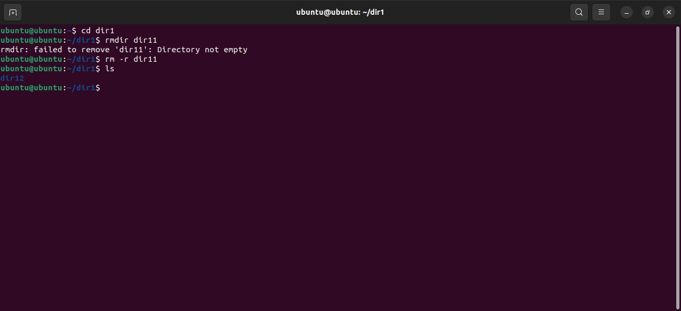

b. Then remove dir12 using rmdir –p command. State what happened to the

hierarchy (Note: you are in your home directory).

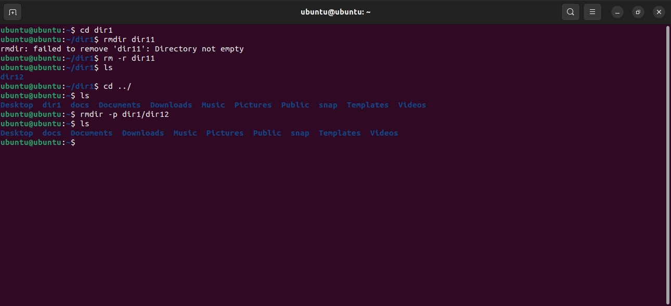

c. The output of the command pwd was /home/user. Write the absolute

and relative path for the file mycv

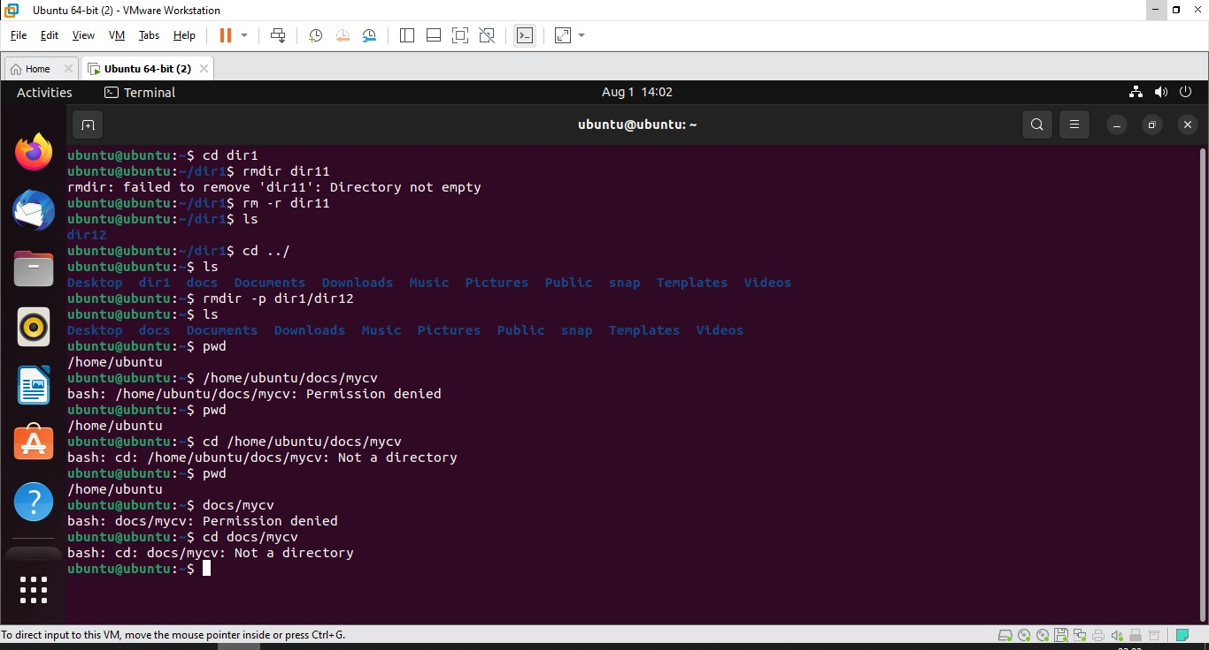

7. You are in /usr/bin, list four ways to go to your home directory

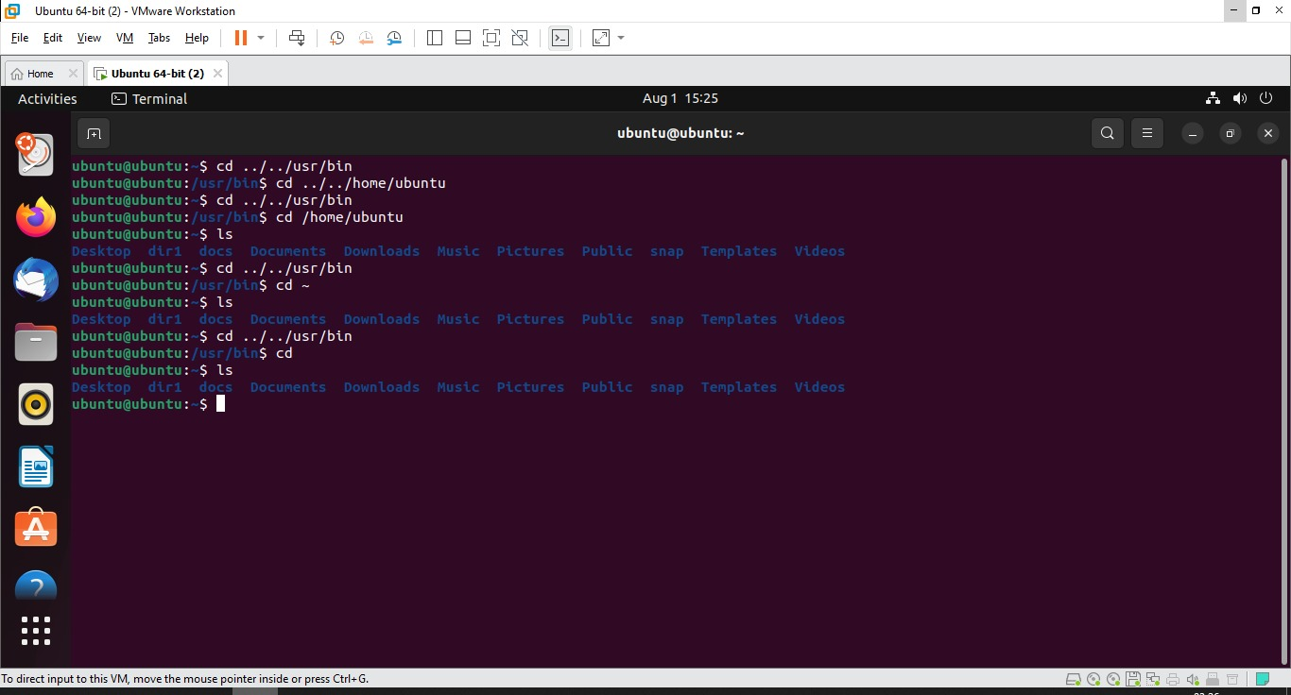

9. Display the first 4 lines of /etc/passwd

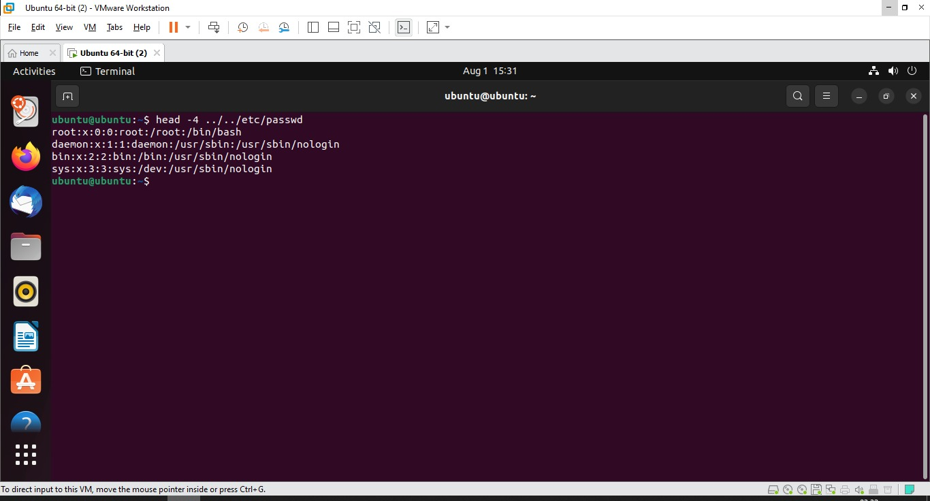

10.Display the last 7 lines of /etc/passwd

